Appendix
Female Recipes
Almond Fig Banana Smoothie  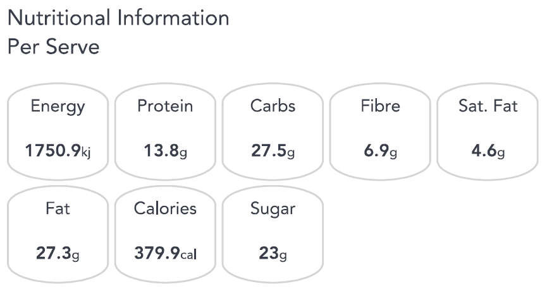 | Broccoli Lentil Apple Salad  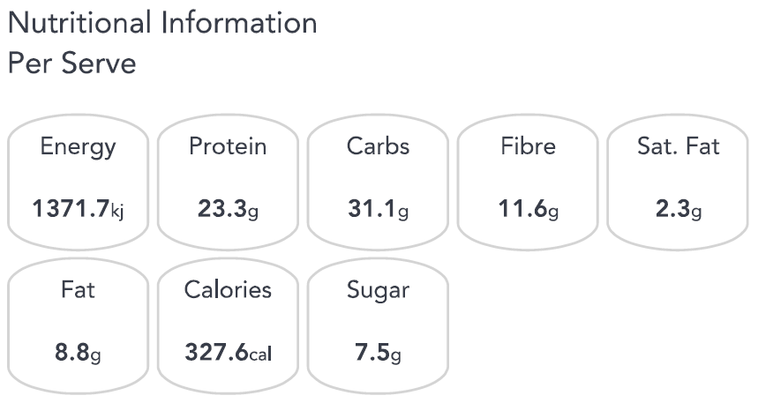
Nectarine and Blueberry Overnight Oats  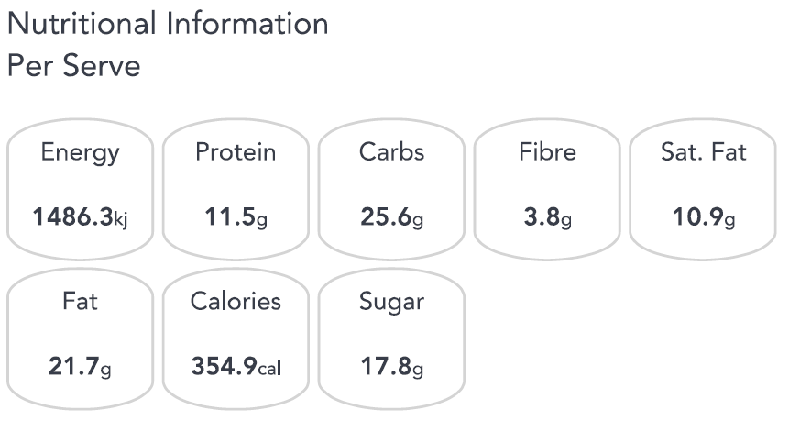 | Beef and Broccoli Stir-Fry  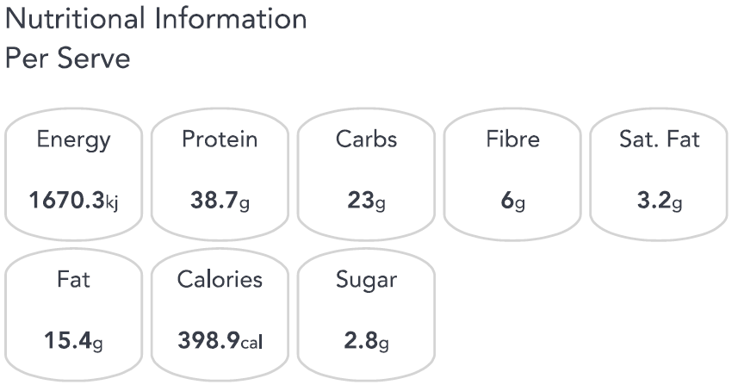
Fish and Sweet Potato Chips  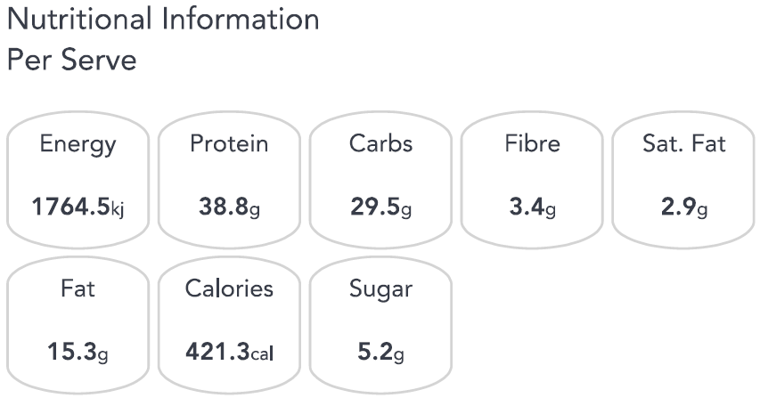 | Grilled Thai Beef Salad  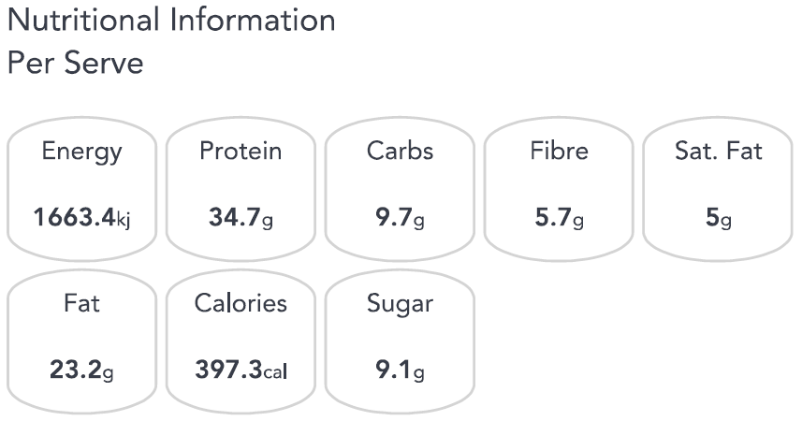
Breakfast Bruschetta  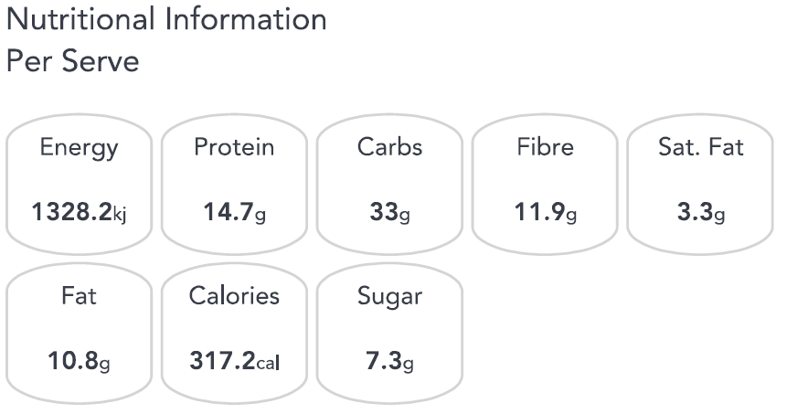 | Spiralised Zucchini Hash  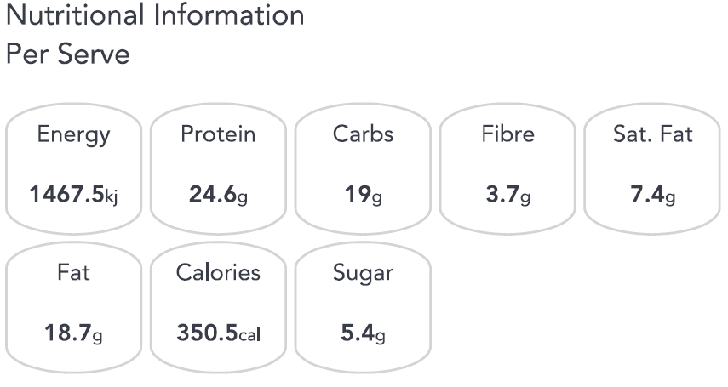
Thai Fish Cakes  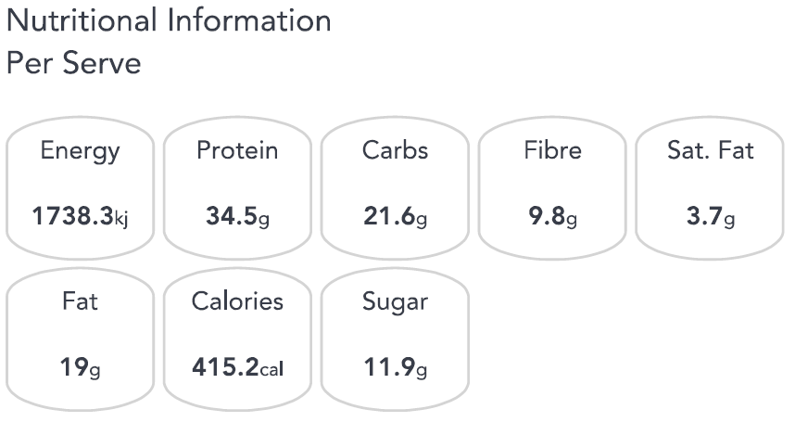 | Pumpkin and Cheese Quesadilla  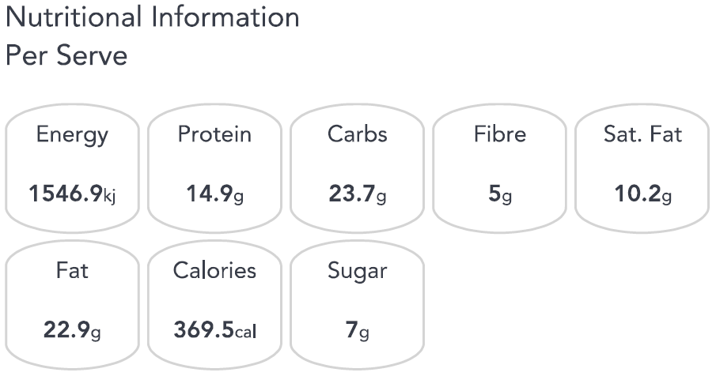
Greek Pies  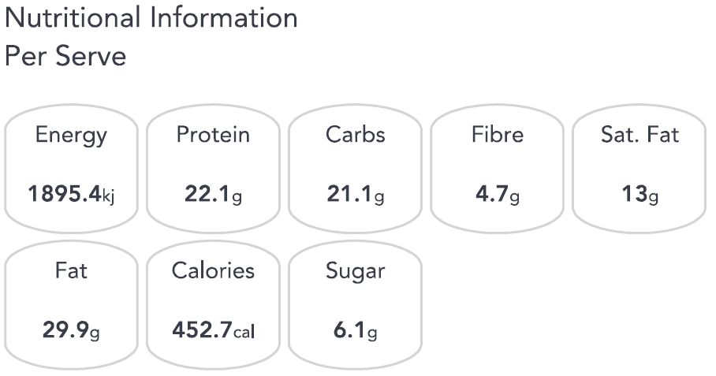 | Banana and Almond Overnight Oats  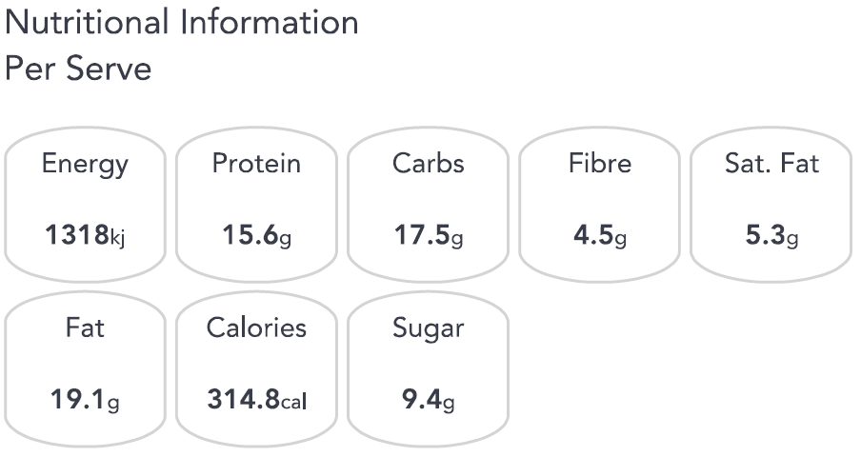
Tandoori Fish with Avocado Salad  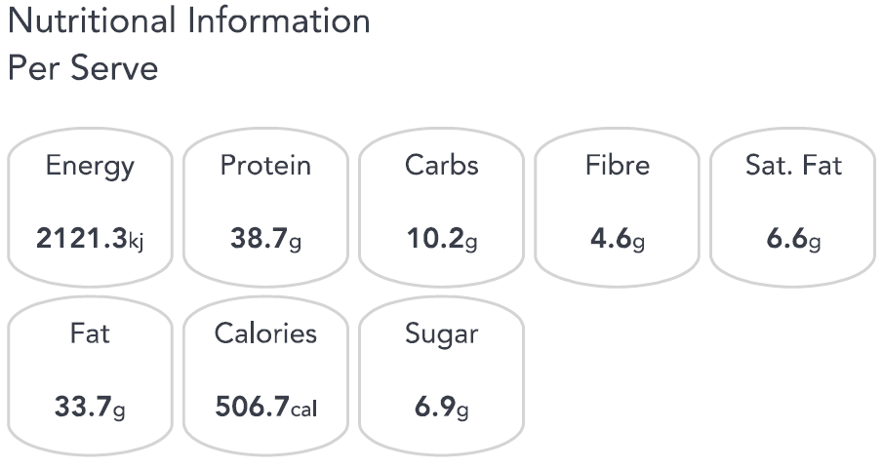 | Roasted Vegetable Chicken Salad  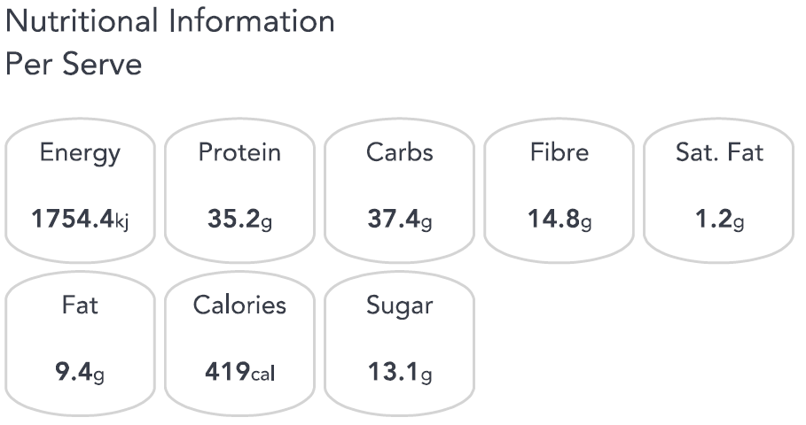
Pocket Pitas with Grilled Fish  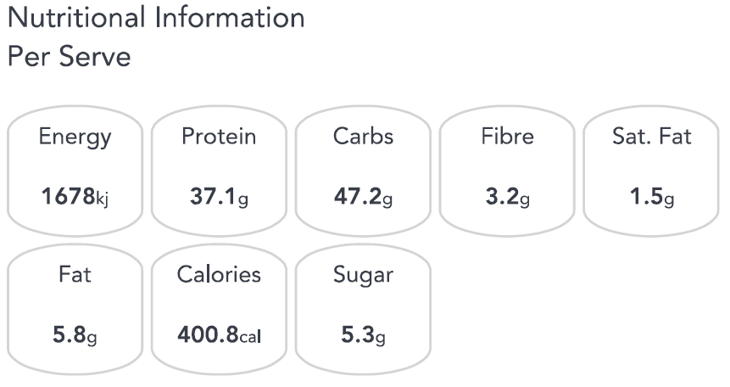 | Almond Hit Smoothie  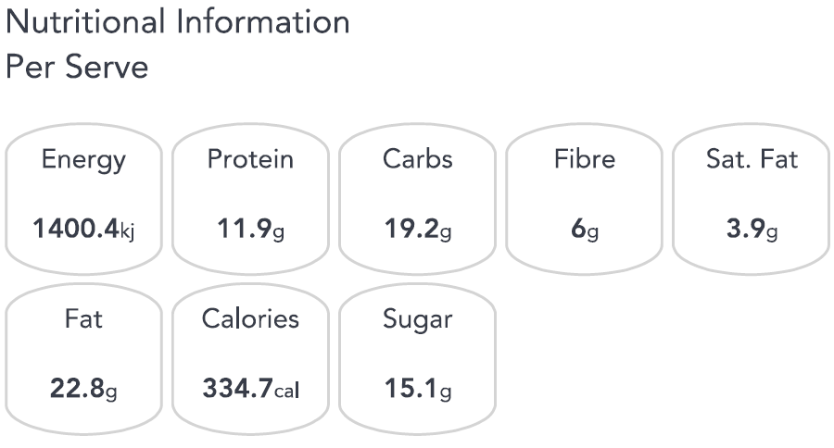

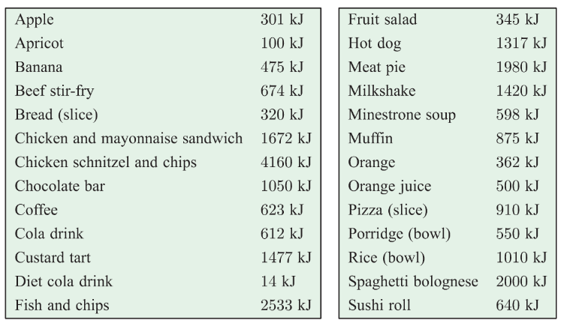

Male Recipes
Almond Fig Banana Smoothie  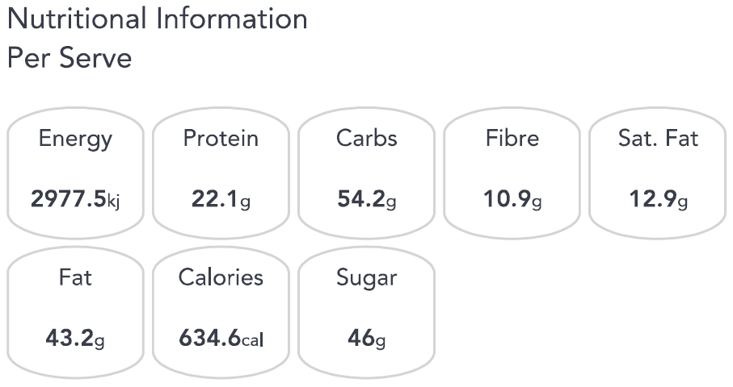 | Broccoli Lentil Apple Salad  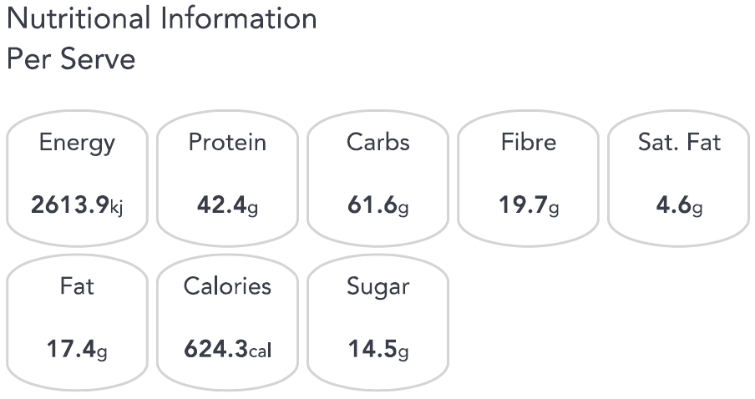
Nectarine and Blueberry Overnight Oats  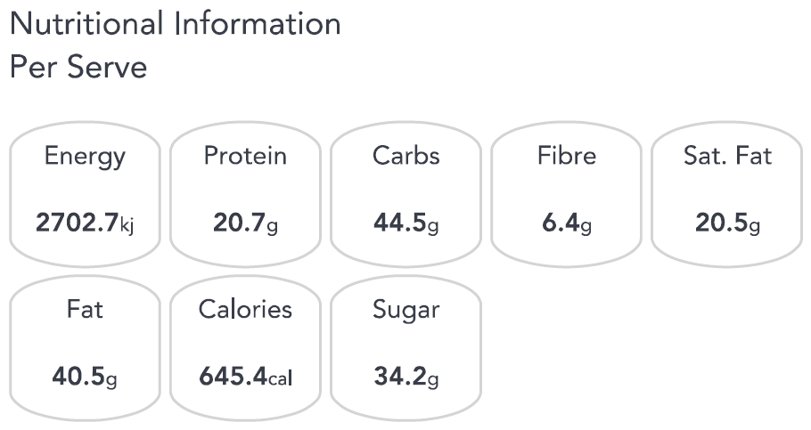 | Beef and Broccoli Stir-Fry  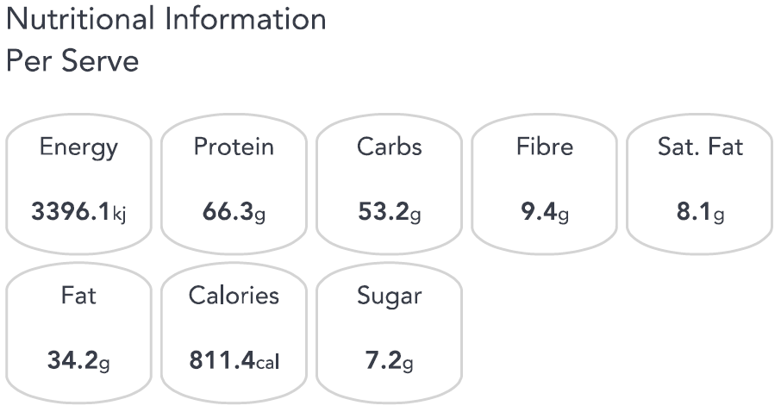
Fish and Sweet Potato Chips  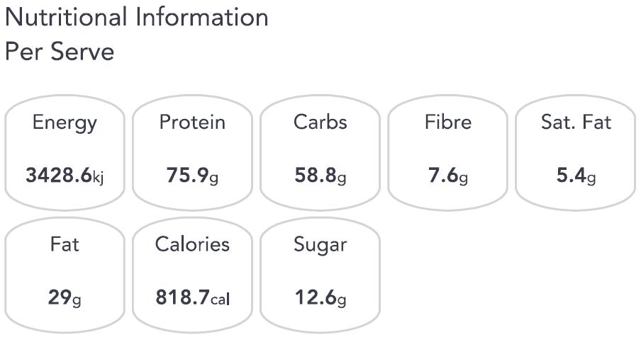 | Grilled Thai Beef Salad  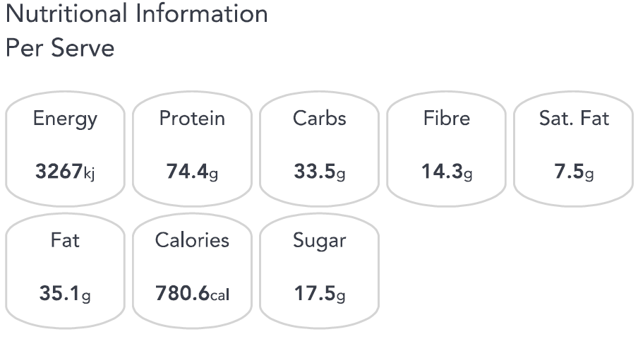
Breakfast Bruschetta  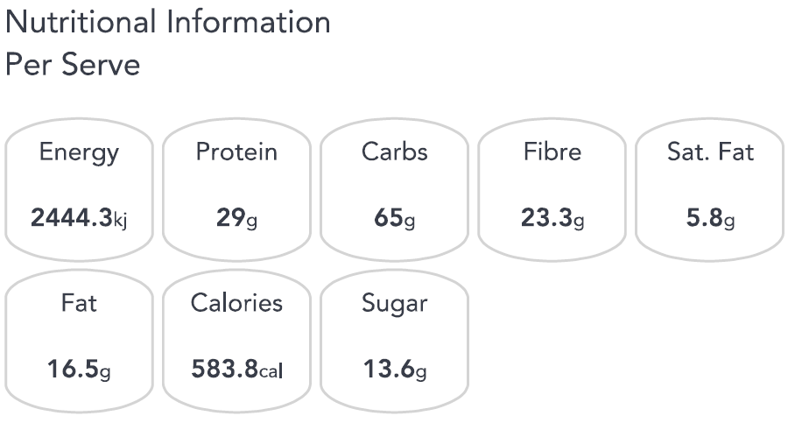 | Spiralised Zucchini Hash  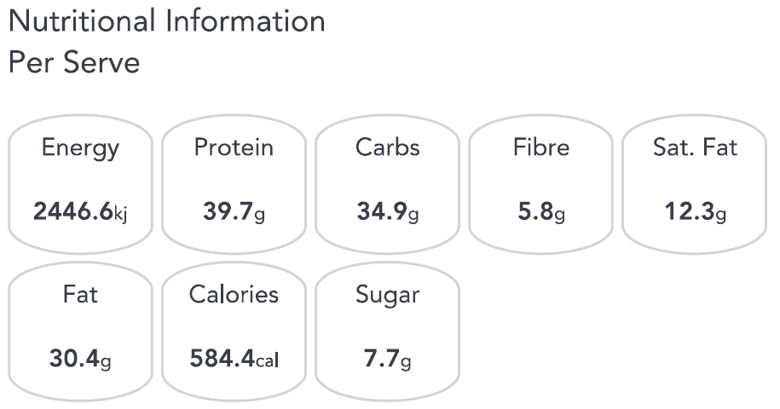
Thai Fish Cakes  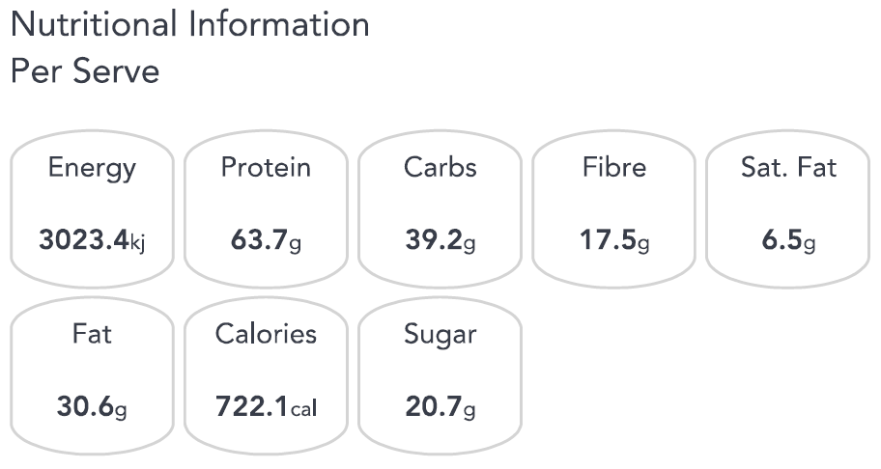 | Cherry Ripe Smoothie  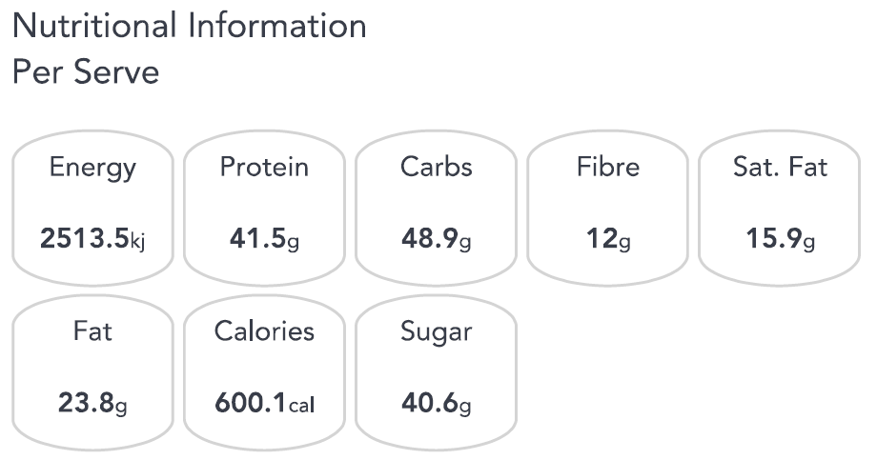
BBQ Lemon Chicken with Potato Salad  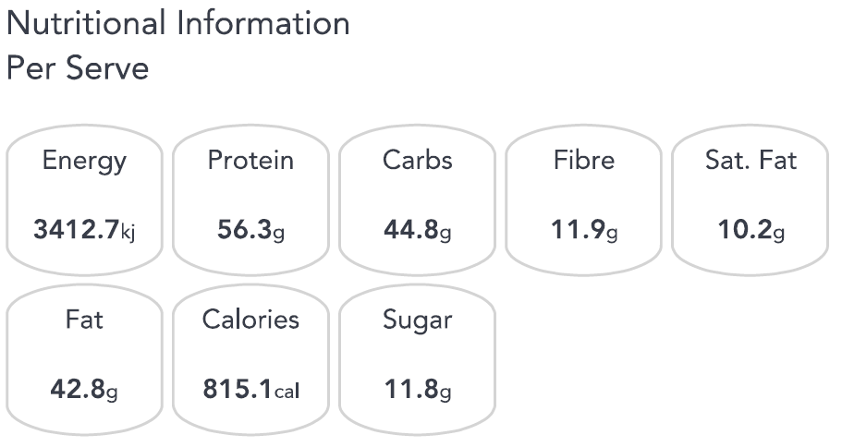 | Smashed Chickpea and Avo Wrap  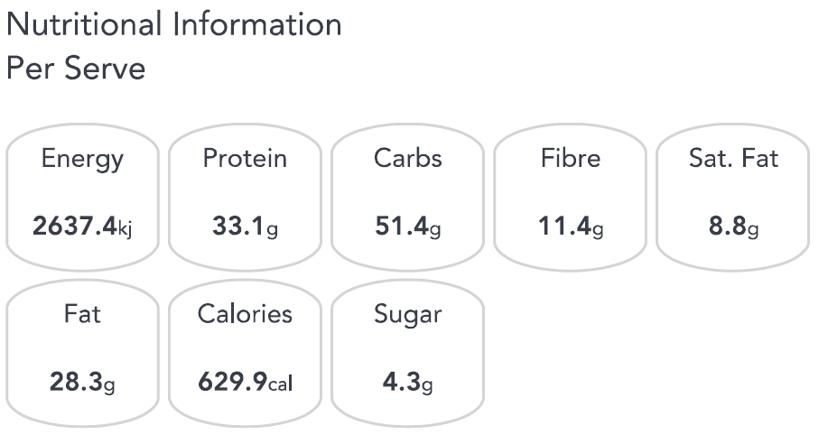
Lamb Souvlaki  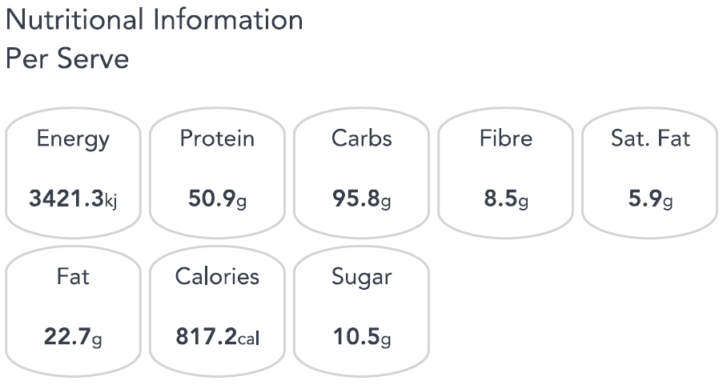 | Quick Banana Pancakes  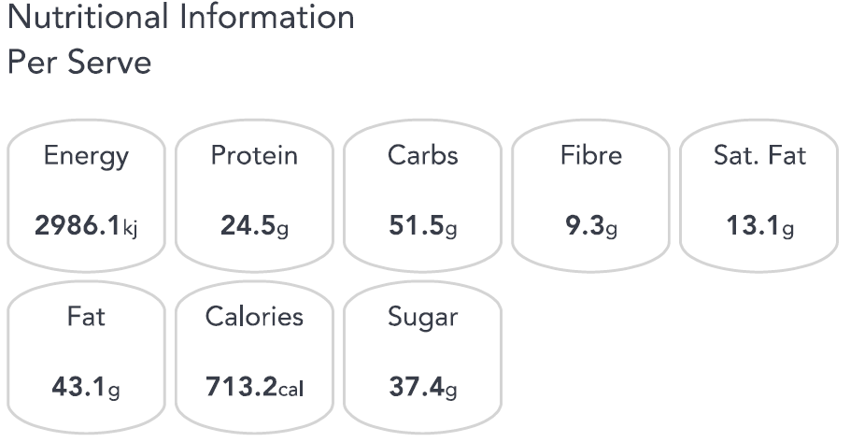
Salmon Patties with a Bean Salad  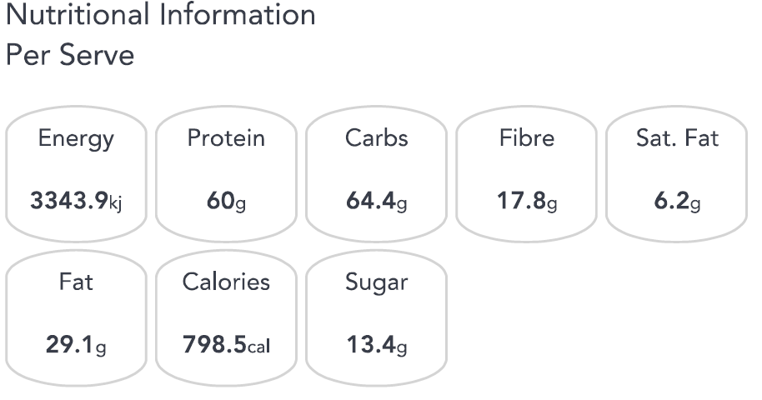 | Chicken Schnitzel with Apple Slaw  